**Exercise 6: Cursors**

**Scenario 1:** Generate monthly statements for all customers.

**Question:** Write a PL/SQL block using an explicit cursor **GenerateMonthlyStatements** that retrieves all transactions for the current month and prints a statement for each customer.

DECLARE

CURSOR GenerateMonthlyStatements IS

SELECT c.CustomerID, c.Name, t.TransactionDate, t.Amount, t.TransactionType

FROM Customers c

JOIN Accounts a ON c.CustomerID = a.CustomerID

JOIN Transactions t ON a.AccountID = t.AccountID

WHERE EXTRACT(MONTH FROM t.TransactionDate) = EXTRACT(MONTH FROM SYSDATE)

AND EXTRACT(YEAR FROM t.TransactionDate) = EXTRACT(YEAR FROM SYSDATE)

ORDER BY c.CustomerID, t.TransactionDate;

v_customer_id Customers.CustomerID%TYPE;

v_customer_name Customers.Name%TYPE;

v_transaction_date Transactions.TransactionDate%TYPE;

v_amount Transactions.Amount%TYPE;

v_transaction_type Transactions.TransactionType%TYPE;

v_current_customer_id Customers.CustomerID%TYPE := NULL;

BEGIN

OPEN GenerateMonthlyStatements;

LOOP

FETCH GenerateMonthlyStatements INTO v_customer_id, v_customer_name, v_transaction_date, v_amount, v_transaction_type;

EXIT WHEN GenerateMonthlyStatements%NOTFOUND;

IF v_current_customer_id IS NULL OR v_current_customer_id != v_customer_id THEN

IF v_current_customer_id IS NOT NULL THEN

DBMS_OUTPUT.PUT_LINE('-----------------------------------------');

END IF;

v_current_customer_id := v_customer_id;

DBMS_OUTPUT.PUT_LINE('Customer ID: ' || v_customer_id);

DBMS_OUTPUT.PUT_LINE('Customer Name: ' || v_customer_name);

DBMS_OUTPUT.PUT_LINE('Transactions for the month:');

DBMS_OUTPUT.PUT_LINE('-----------------------------------------');

DBMS_OUTPUT.PUT_LINE('Date | Amount | Type');

DBMS_OUTPUT.PUT_LINE('-----------------------------------------');

END IF;

DBMS_OUTPUT.PUT_LINE(TO_CHAR(v_transaction_date, 'YYYY-MM-DD') || ' | ' ||

TO_CHAR(v_amount, '99999.99') || ' | ' ||

v_transaction_type);

END LOOP;

IF v_current_customer_id IS NOT NULL THEN

DBMS_OUTPUT.PUT_LINE('-----------------------------------------');

END IF;

CLOSE GenerateMonthlyStatements;

END;

/

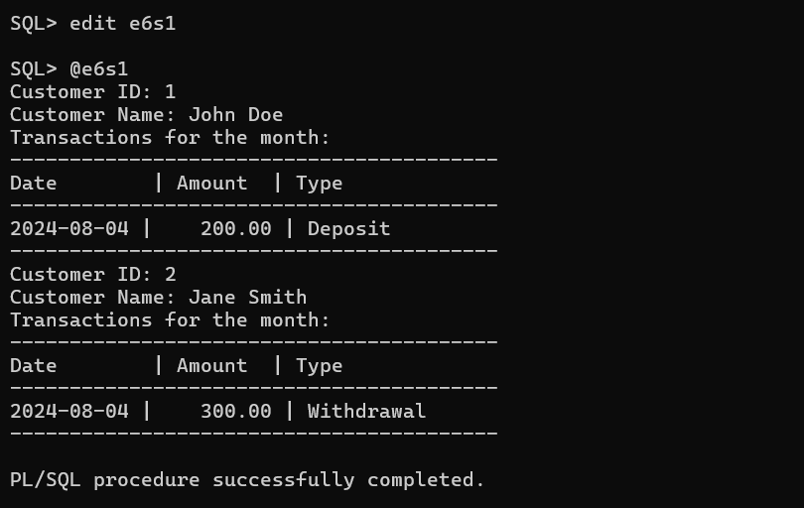

**Scenario 2:** Apply annual fee to all accounts.

**Question:** Write a PL/SQL block using an explicit cursor **ApplyAnnualFee** that deducts an annual maintenance fee from the balance of all accounts.

SET SERVEROUTPUT ON;

DECLARE

CURSOR ApplyAnnualFee IS

SELECT AccountID, Balance

FROM Accounts

FOR UPDATE OF Balance;

v_account_id Accounts.AccountID%TYPE;

v_balance Accounts.Balance%TYPE;

v_annual_fee NUMBER := 50; -- Example annual fee

BEGIN

OPEN ApplyAnnualFee;

LOOP

FETCH ApplyAnnualFee INTO v_account_id, v_balance;

EXIT WHEN ApplyAnnualFee%NOTFOUND;

v_balance := v_balance - v_annual_fee;

UPDATE Accounts

SET Balance = v_balance,

LastModified = SYSDATE

WHERE CURRENT OF ApplyAnnualFee;

DBMS_OUTPUT.PUT_LINE('Account ID: ' || v_account_id || ' - New Balance: ' || v_balance);

END LOOP;

CLOSE ApplyAnnualFee;

END;

/

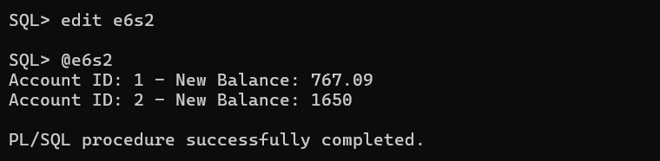

**Scenario 3:** Update the interest rate for all loans based on a new policy.

**Question:** Write a PL/SQL block using an explicit cursor **UpdateLoanInterestRates** that fetches all loans and updates their interest rates based on the new policy.

SET SERVEROUTPUT ON;

DECLARE

CURSOR UpdateLoanInterestRates IS

SELECT LoanID, InterestRate

FROM Loans

FOR UPDATE OF InterestRate;

v_loan_id Loans.LoanID%TYPE;

v_interest_rate Loans.InterestRate%TYPE;

v_new_interest_rate NUMBER;

BEGIN

OPEN UpdateLoanInterestRates;

LOOP

FETCH UpdateLoanInterestRates INTO v_loan_id, v_interest_rate;

EXIT WHEN UpdateLoanInterestRates%NOTFOUND;

v_new_interest_rate := v_interest_rate + 1;

UPDATE Loans

SET InterestRate = v_new_interest_rate

WHERE CURRENT OF UpdateLoanInterestRates;

DBMS_OUTPUT.PUT_LINE('Loan ID: ' || v_loan_id || ' - New Interest Rate: ' || v_new_interest_rate);

END LOOP;

CLOSE UpdateLoanInterestRates;

END;

/

